# AI ASSISSTED CODING LAB EXAM-2

NAME: SIRIVELLA SANJANA

ROLLNO: 2403A510D4

BATCH NO: 05

SUBGROUP-D

**TASK:1**

Scenario (sports analytics):  
Context:  
File versioning in the sports analytics data pipeline uses a `_vNN` suffix before the extension.  
Your Task:  
Create tests and implement bump_version(name) that adds or increments `_vNN` with zero-  
padding.  
Data & Edge Cases:  
Handle names with and without existing suffix; preserve original extension.  
AI Assistance Expectation:  
Use AI to propose regex and test cases for edge names like `report_v9.csv`, `summary.csv`.  
Constraints & Notes:  
Preserve original extension and base name.  
Sample Input  
['report_v1.csv', 'summary.csv', 'log_v09.txt']  
Sample Output  
['report_v02.csv', 'summary_v01.csv', 'log_v10.txt']  
Acceptance Criteria: Correct zero-padding; extension preserved

**PROMPT:**

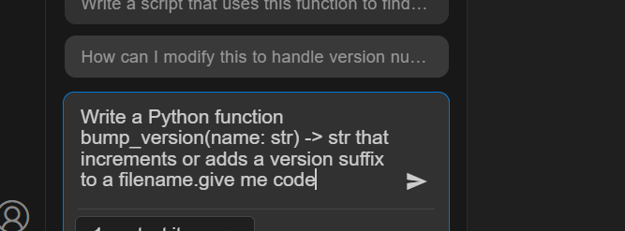

**CODE:**

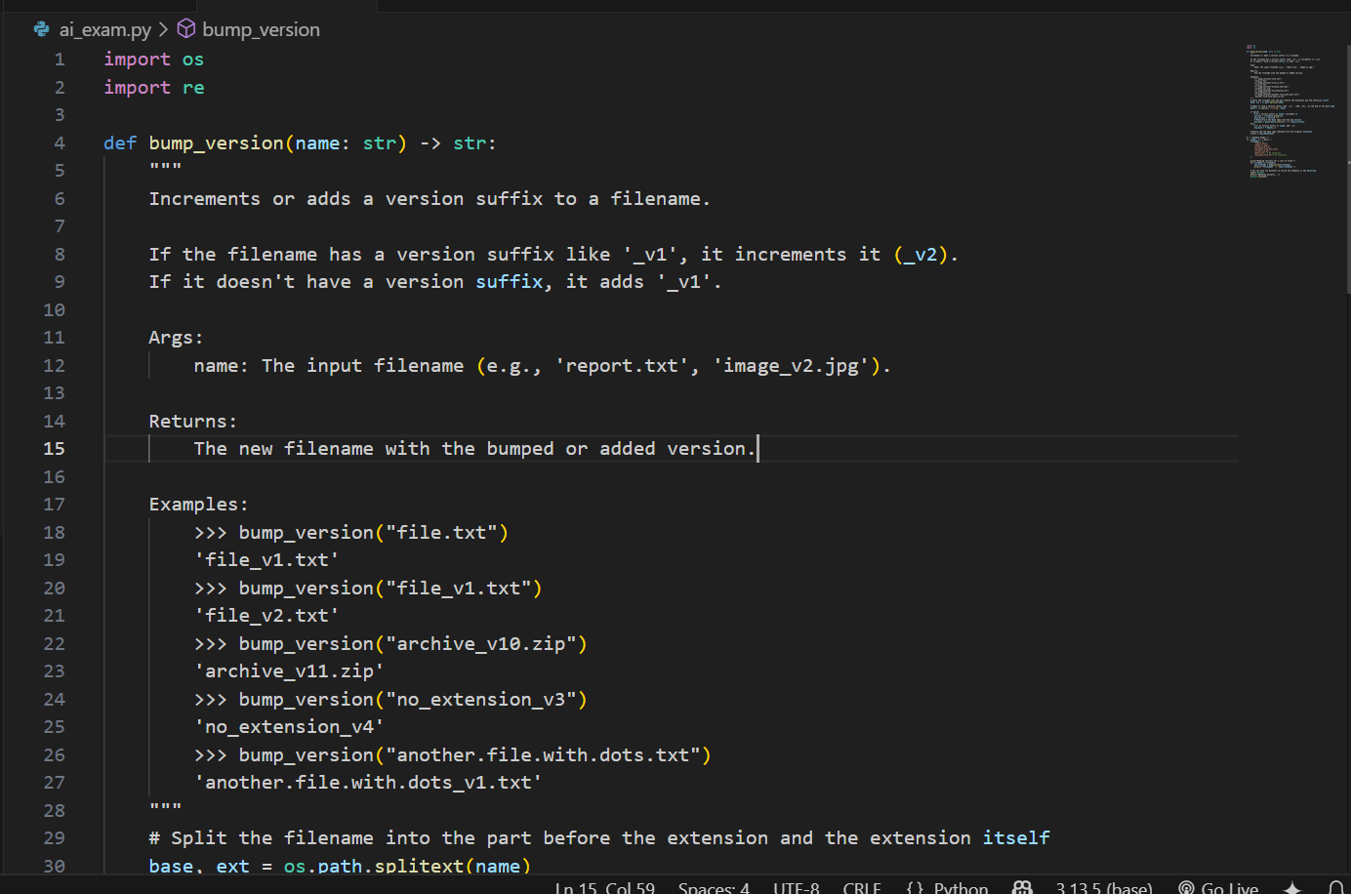

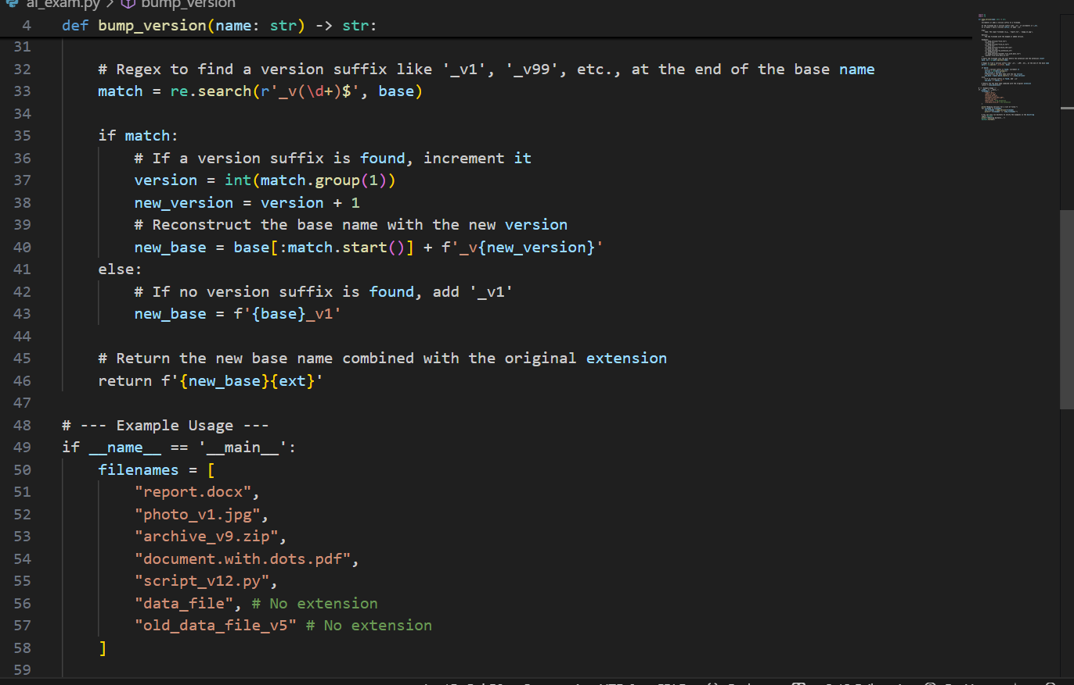

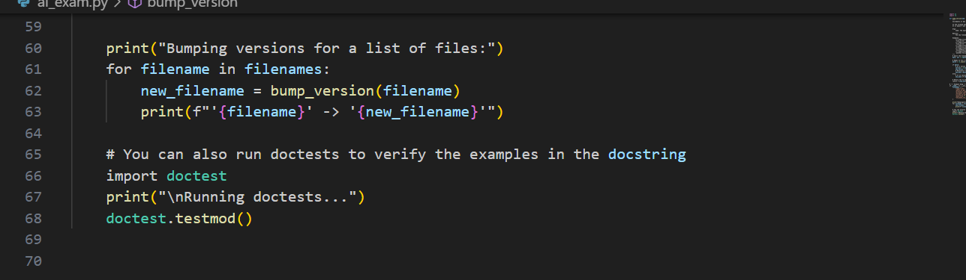

**OUTPUT:**

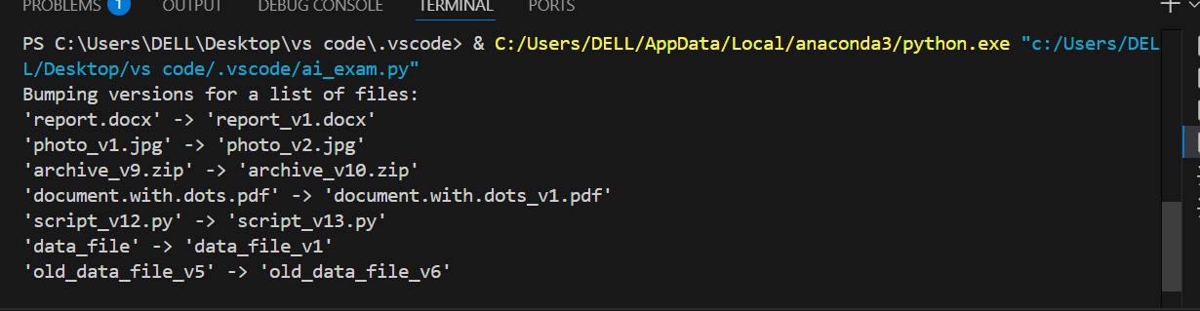

**OBSERVATIONS:**

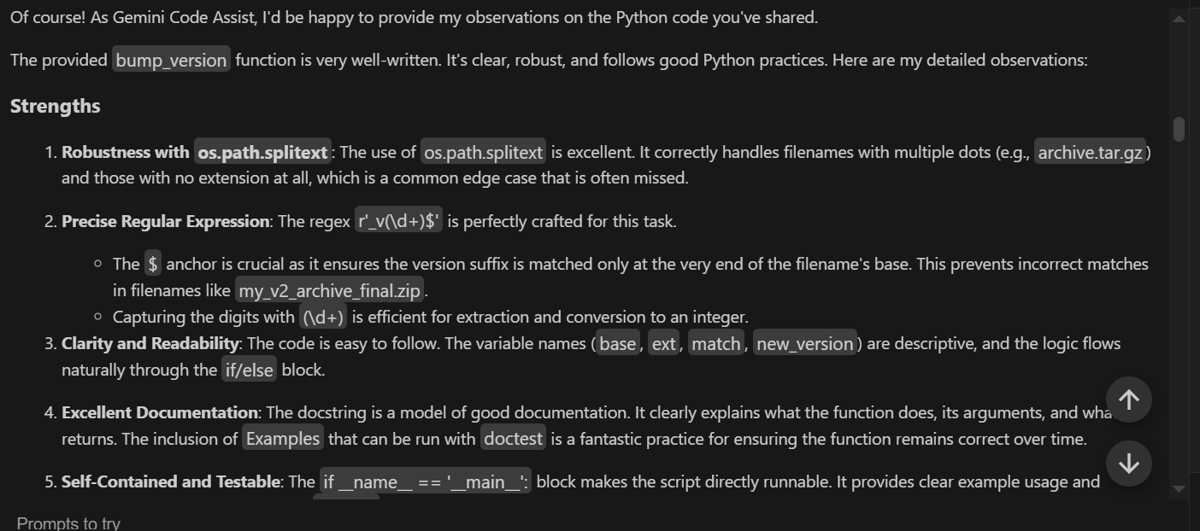

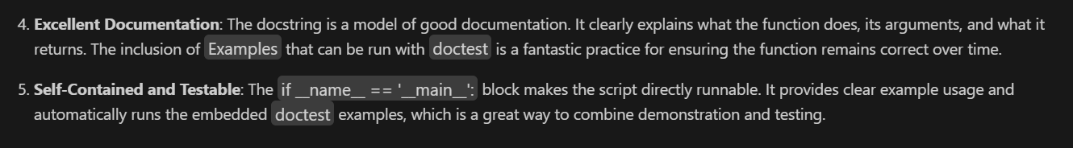

**TASK:2**

Scenario (sports analytics):  
Context:

Data analysts in sports analytics normalize metrics to [0,1] for comparability.  
Your Task:  
Add Google-style docstrings and handle the edge-case where all scores are equal (avoid divide-  
by-zero).  
Data & Edge Cases:  
Empty lists return empty; if max==min, return zeros of the same length.  
AI Assistance Expectation:  
Use AI to draft docstrings with Args/Returns/Examples and generate unit tests for edge-cases.  
Constraints & Notes:  
Add tests demonstrating the m==n case.  
Sample Input  
def normalize(scores):  
m = max(scores); n = min(scores)  
return [(x-n)/(m-n) for x in scores]  
Sample Output  
Docstring includes Args/Returns/Examples; guard for m==n  
Acceptance Criteria: Doc quality and guard confirmed by tests.

**PROMPT:**

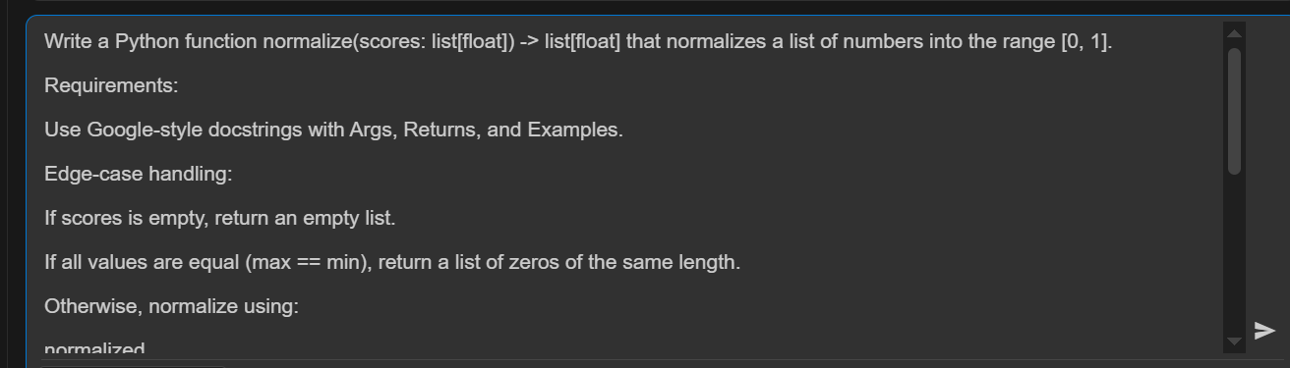

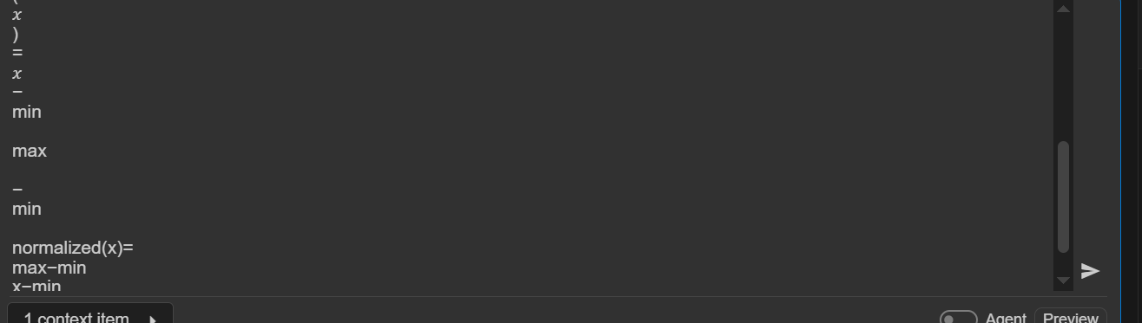

**CODE:**

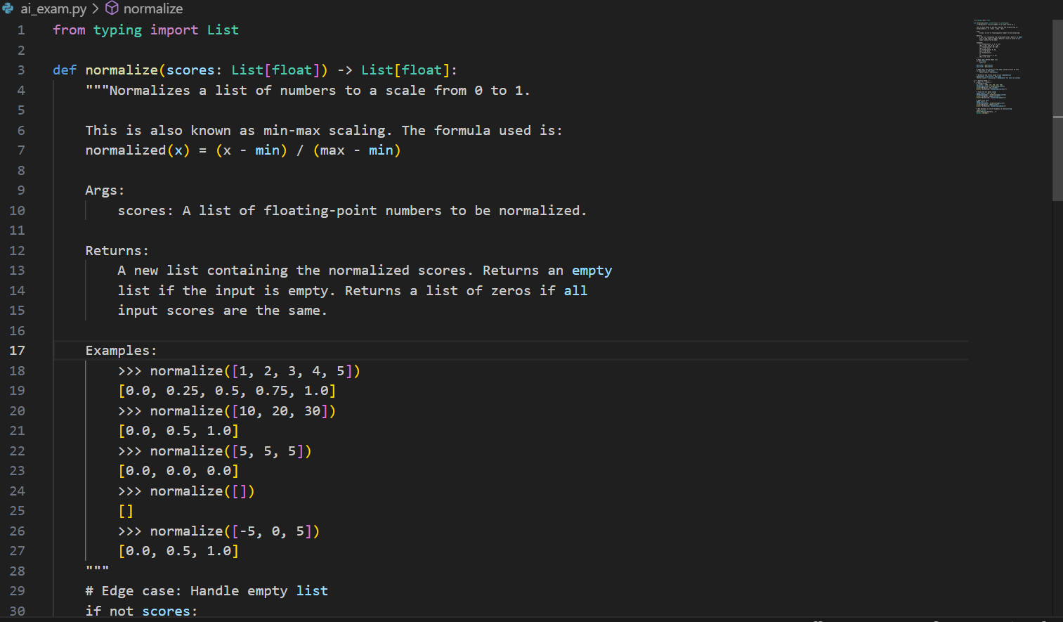

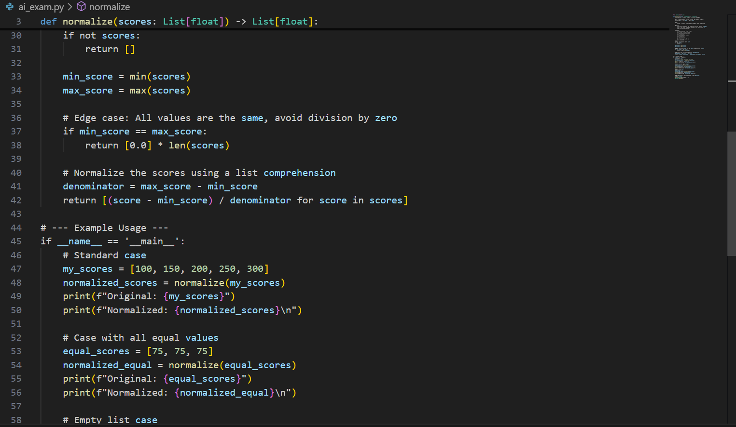

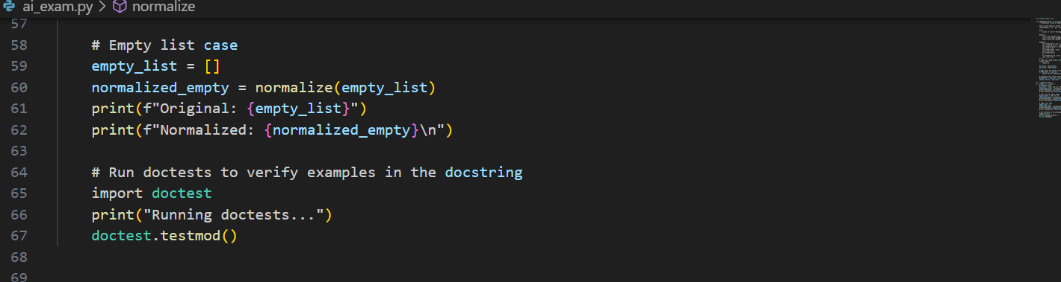

**OUTPUT:**

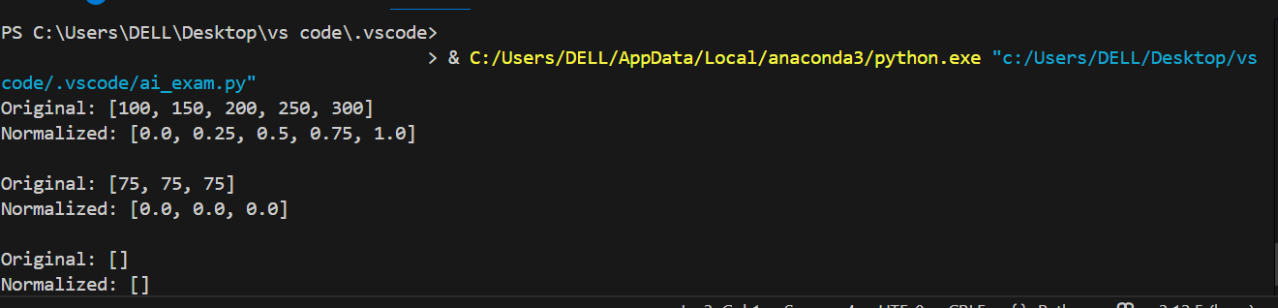

**OBSERVATIONS:**

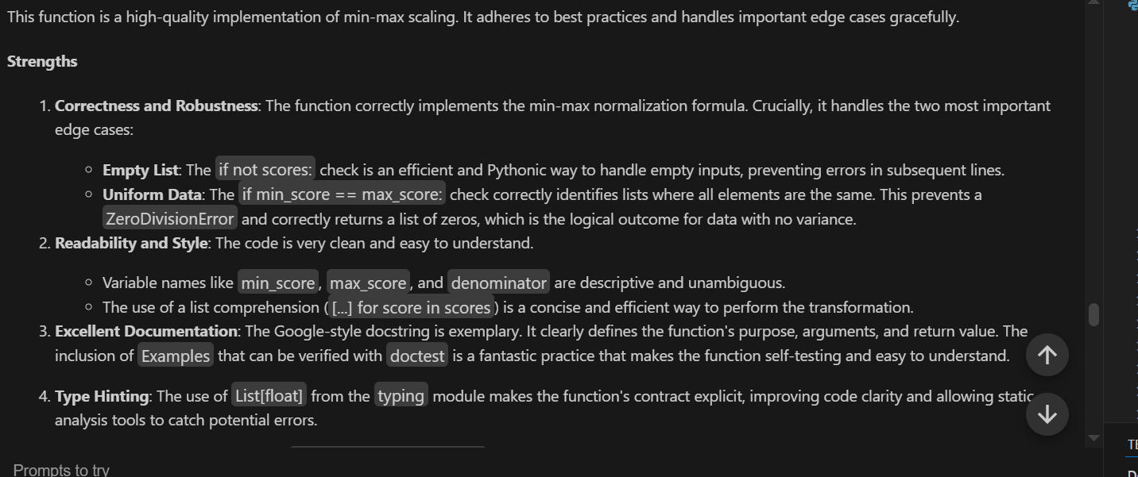



-----------------------THE END--------------------------